- Offer and Specification for my Report

Customer: Shubham Adhikari my brother friend, launching an online Nepalese clothing brand.

Title: Dhago Clothing-Authentic Nepalese Wear

Target audience:
- Young Nepalese Men and Women(18-35) looking for trendy yet cultural outfits
- International customers interested in ethnic /Nepalese clothing

Purpose of site:
- Showcase and sell clothes online
- Build a brand identity for Nepalese fashion
- Provide product details, contact info, and ordering options

Customer´s starting point:
- Only has social media (Instagram, Tiktok). No official website yet.
- Wants a simple, stylish and mobile-friendly e-commerce-style site.

Specifications:
- 4+ pages: Home, Shop/Products, About Us, Contact
- Responsive design (works on phone, tablet, computer).
- Clear navigation with a logo and consistent branding.
- Integrated product gallery with categories.
- Contact form + map for physical location.
- Limitations: No smartwatch version, but mobile & desktop optimized.

More Information:
- Once the site is coded, he cannot directly edit text without web tools
- This project mainly focuses on HTML/CSS.

- Plan:
- Pages: The site will have minimum 4 pages.
- Home: Brand Intro, Main image, highlights of collection
- Products: Grids of cloths with image, prices and short description
- About us: Story of the brand, Nepalese culture in clothing, mission
- Contact: Contact form, Open street map, social links

- Site diagram:

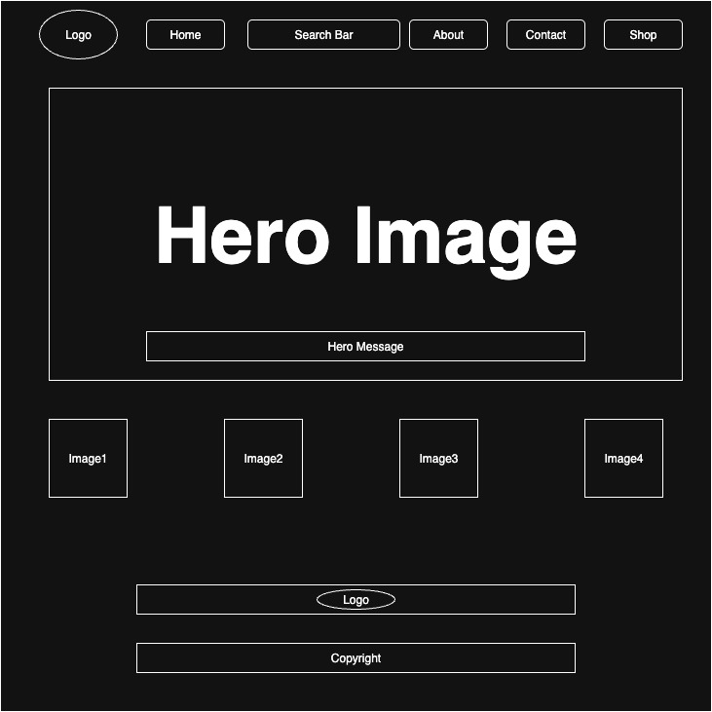

Layout ideas:
- Logo top-left, navigation top-right
- Large hero image on homepage (e.g., Nepali cotton sawl photo)
- Product grid using flexbox/grid in Shop page
- Footer on all pages with contact info & social media
Color Scheme:
- Primary: Dark grayish lime green (#415d43)→Connects Nepal with nature
- Secondary: Blue lagoon (#007185)
Fonts:
- Headings: Arial,Helvetica, sans-serif (modern, bold)
- Body text: Arial,Helvetica, sans-serif(clean, readable)

